**GOOGLE ASSISTANT ACTIONS USING NODE JS**

## Follow the complete process: <https://www.youtube.com/watch?v=5_0MSxCIeE8>

- Installing NodeJS

1. nodejs - https://nodejs.org/en/

2. Dialogflow - https://dialogflow.com/

<https://cloud.google.com/dialogflow/es/docs/agents-manage>

follow this link and click on DialogFlow console

3. ngrok - <https://ngrok.com/>

-Download and unzip .Then click then run it.

After run pls put this command to connect the node server:

- `**ngrok http 8050**` (node port )

- Architecture

1. Creating an agent in Dialogflow

2. Creating NodeJS project and installing libraries

3. Creating NodeJS backend for Dialogflow

4. Integrating Dialogflow with NodeJS backend

5. Installing and using ngrok

6. Testing the Dialogflow agent.

7. Deploying it on google assistant.

Follow the pictures for more help:

STEP-1:

<https://cloud.google.com/dialogflow/es/docs/agents-manage>

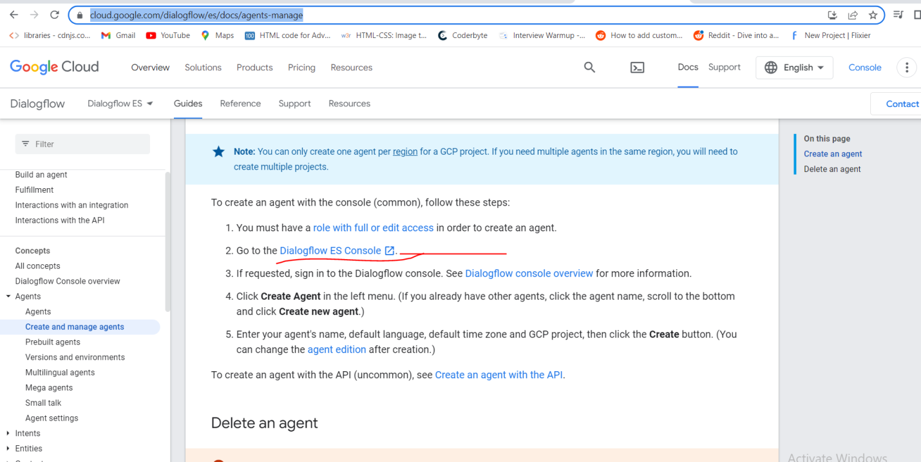

STEP-2:

Create Entities:

1

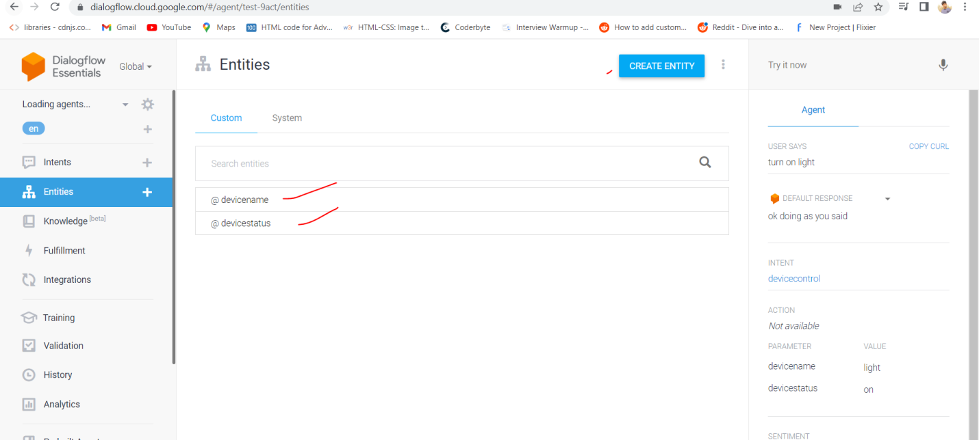

2.

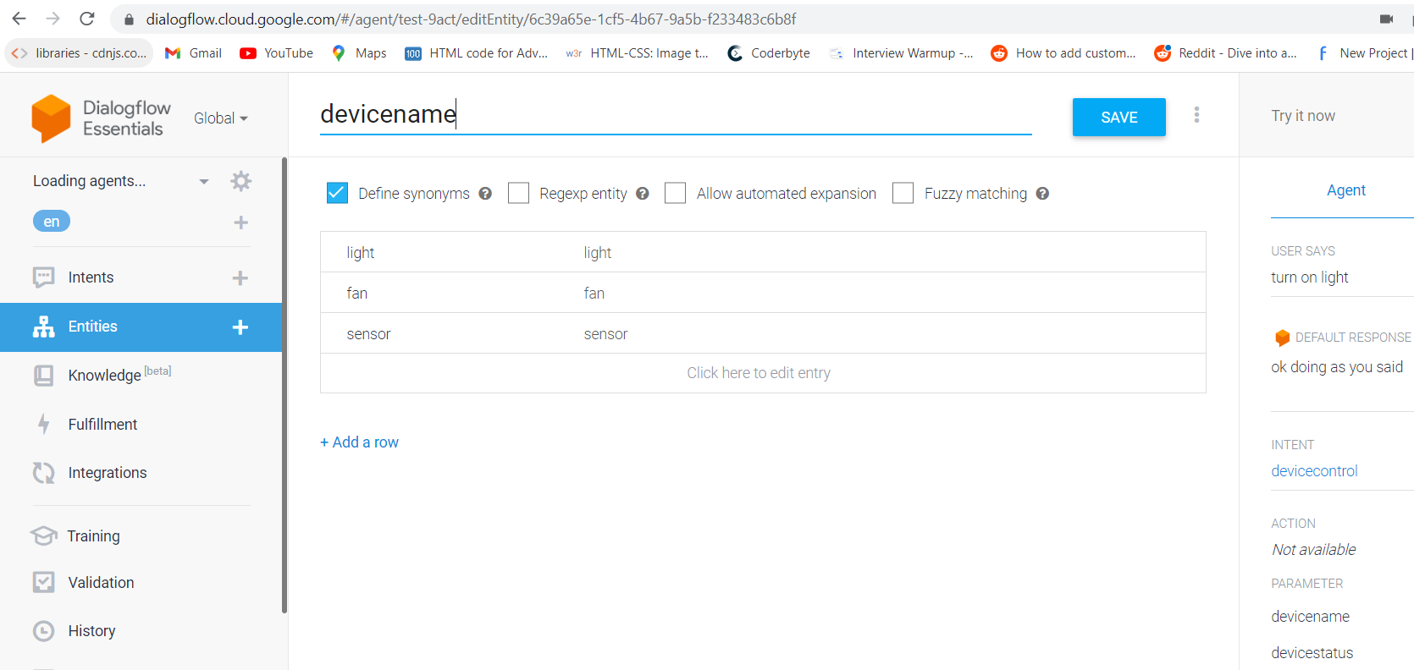

3.

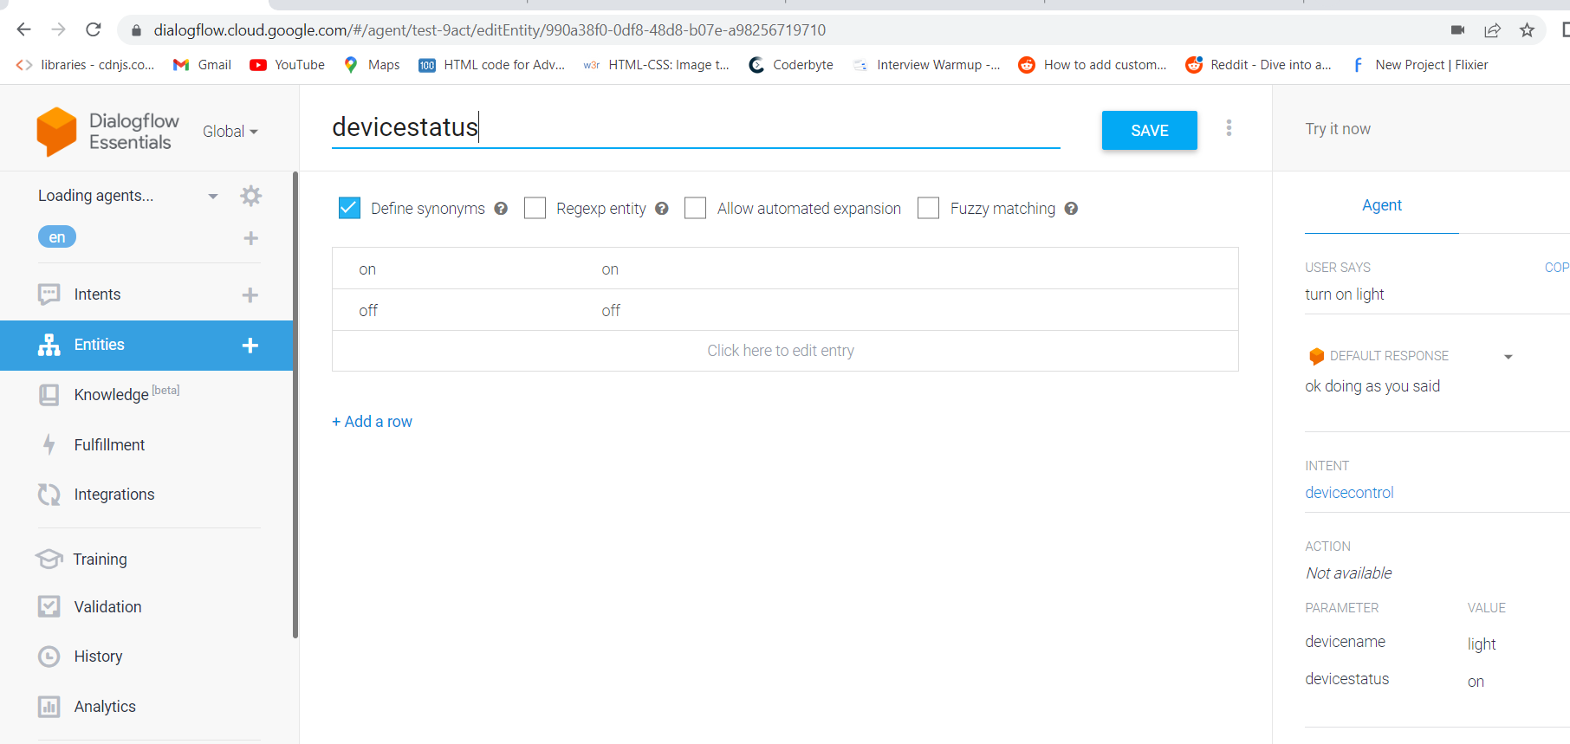

Step-3:

Create Intents:

1

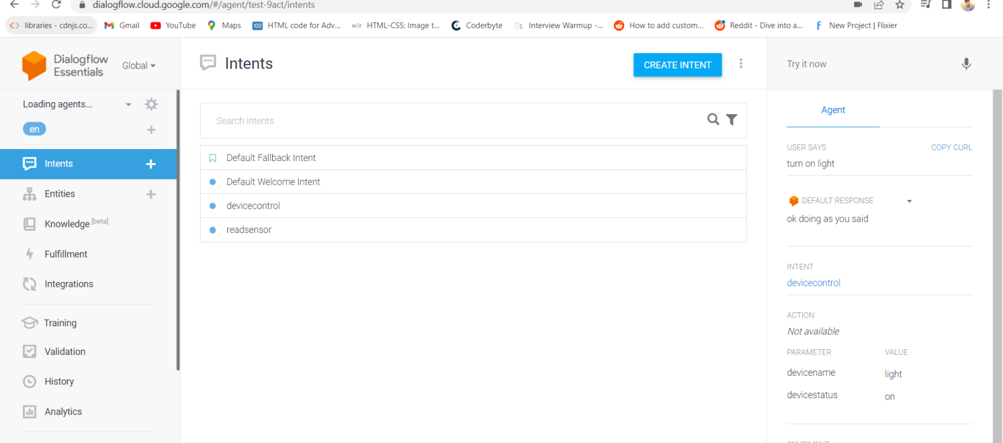

2. Add Response and enable the fullfillment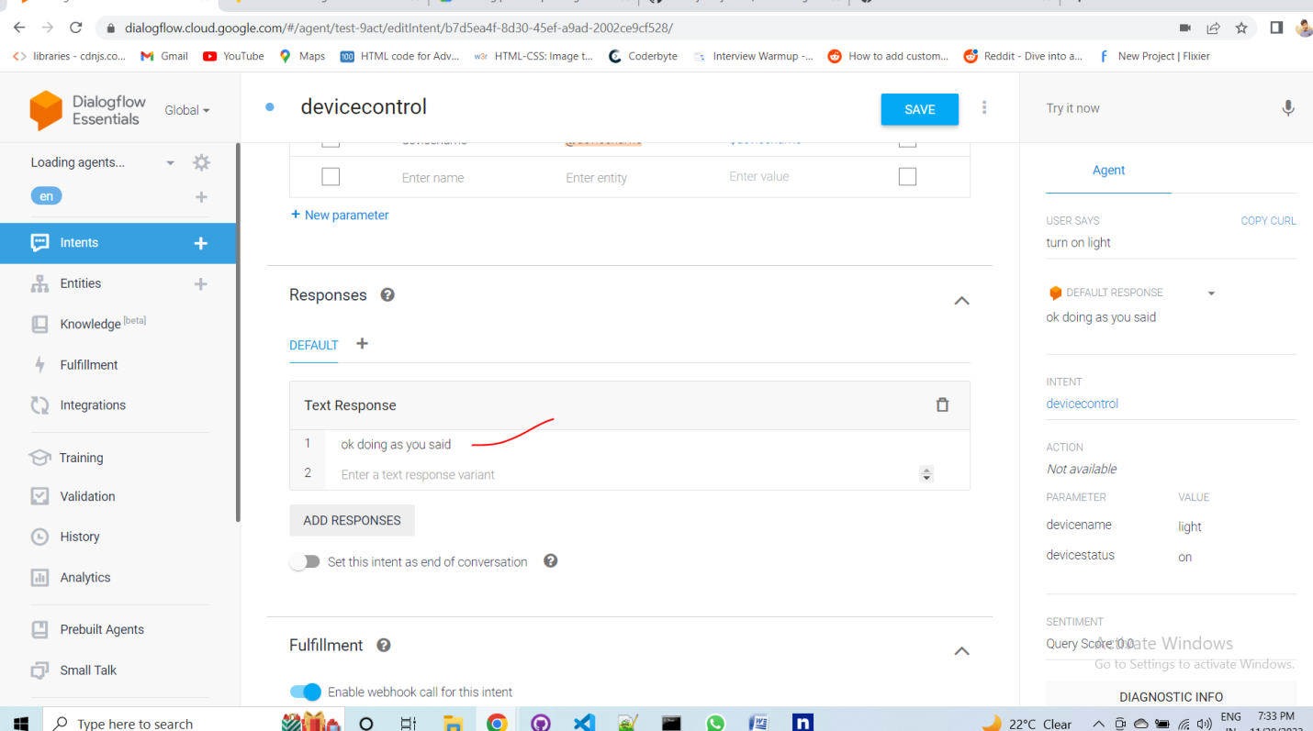

3.

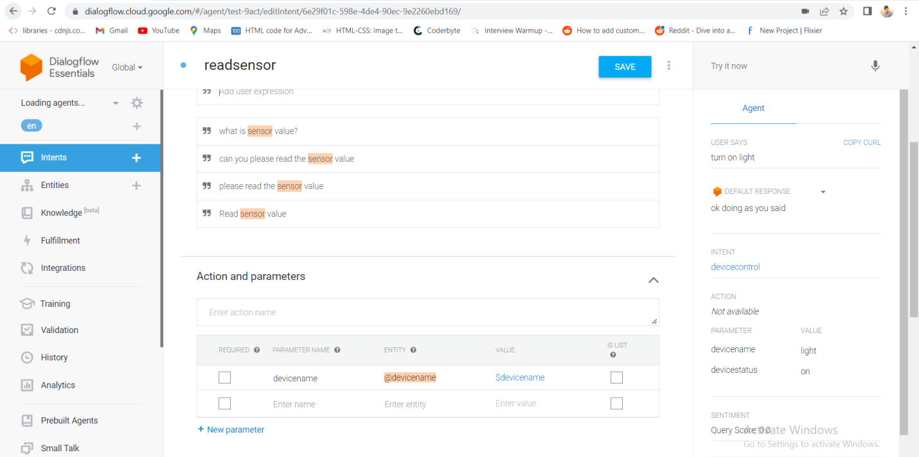

4.add response and enable the fulfillment

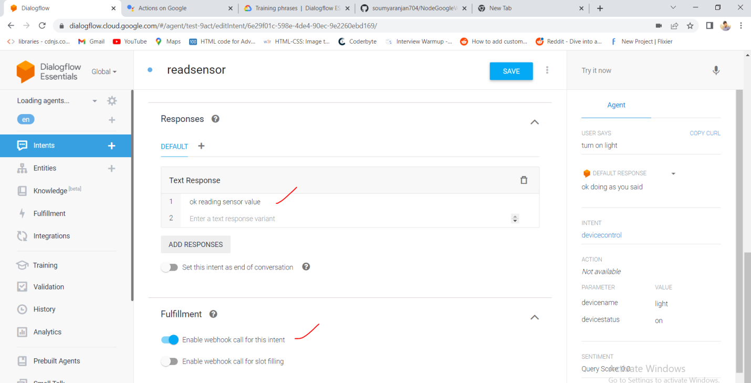

NGROK:It connect to nodeserver

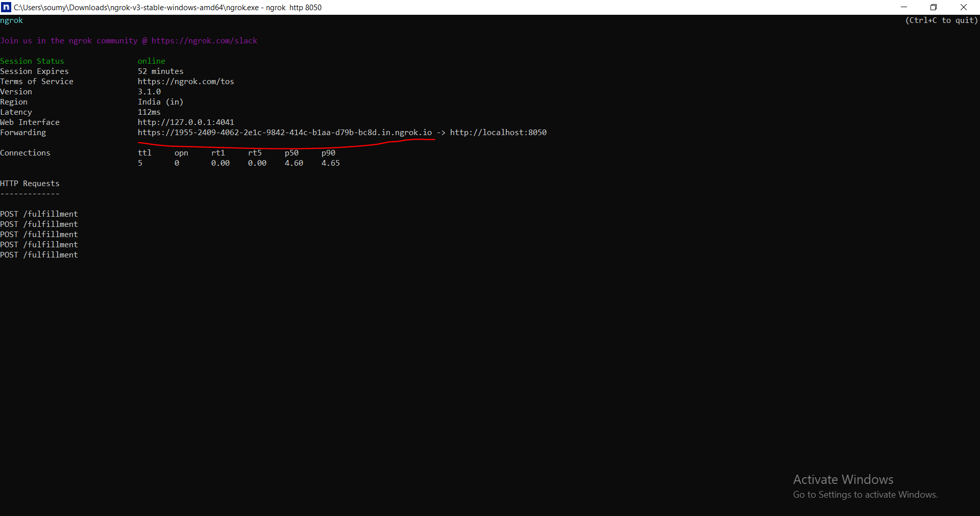

Copy this URL and add it to your dialogflow fullfillment section -fulfillment URL then click the SAVE button.

